Day 30 – NLP Insights

NLP insights are patterns, trends, emotions, or relationships extracted from text data.
Text by itself is messy and unstructured.
Example:
"The delivery was late but the product quality is excellent."
A machine does not naturally understand:
- delivery issue
- positive opinion
- mixed sentiment
NLP techniques convert text into analyzable information.
Visualization of text insights :

Why NLP Visualization Matters:
Raw numbers are useless if nobody understands them.
Visualization helps:
- identify patterns quickly
- communicate findings
- compare text trends
- discover hidden themes
Example:
- A word cloud instantly shows dominant topics.
- A sentiment chart shows customer satisfaction trends.
- Frequency plots reveal recurring complaints.
Visualization turns NLP into decision-making.

Types of Text Insights

A. Word Frequency Analysis
This identifies the most commonly occurring words.
Example:
gme, buy, robinhood
or
[‘gme’,’amc’], [‘buy’,’game’],[‘hedge’,’fund’]

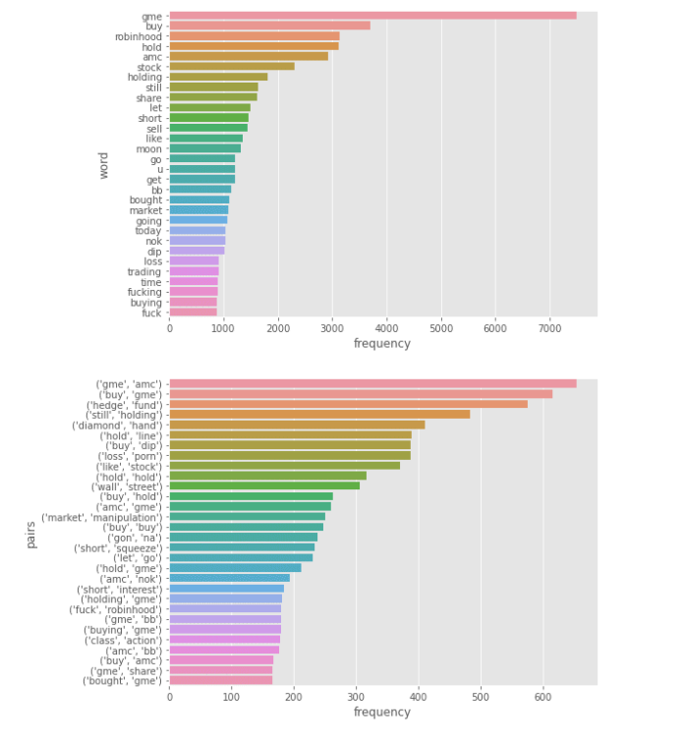

Purpose
Used to:
- identify important discussion topics
- detect repeated complaints
- understand customer focus areas

Limitation
Frequent words are not always meaningful.
Example:
- “the”
- “is”
- “good”
That’s why preprocessing matters.

What Is a Word Cloud?
A word cloud is a visual representation of word frequency.
- Frequently appearing words are shown larger.
- Rare words appear smaller.

Example
In movie reviews:
- “amazing”
- “acting”
- “story”
may appear larger.
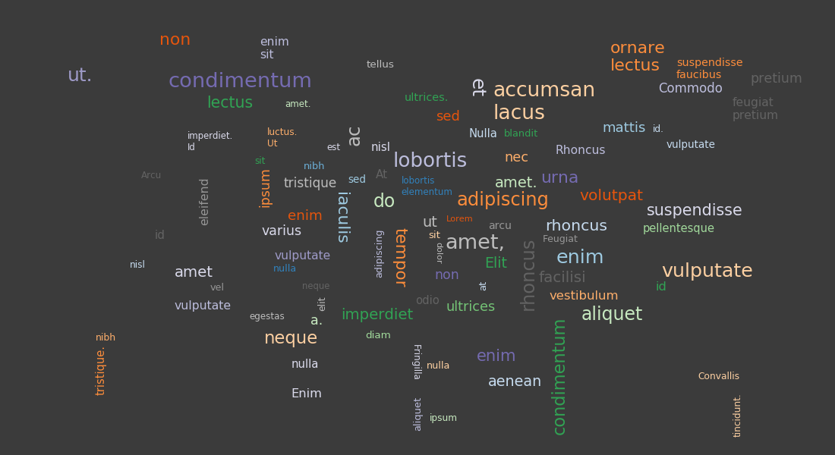

Purpose
Used for:
- presentations
- quick understanding
- identifying dominant themes

Limitation
Word clouds look attractive but are not deeply analytical.
They are supporting visuals, not serious analysis alone.

NLP Visualization Techniques

A. Bar Charts
Used for:
- word frequency
- sentiment counts
- topic distribution
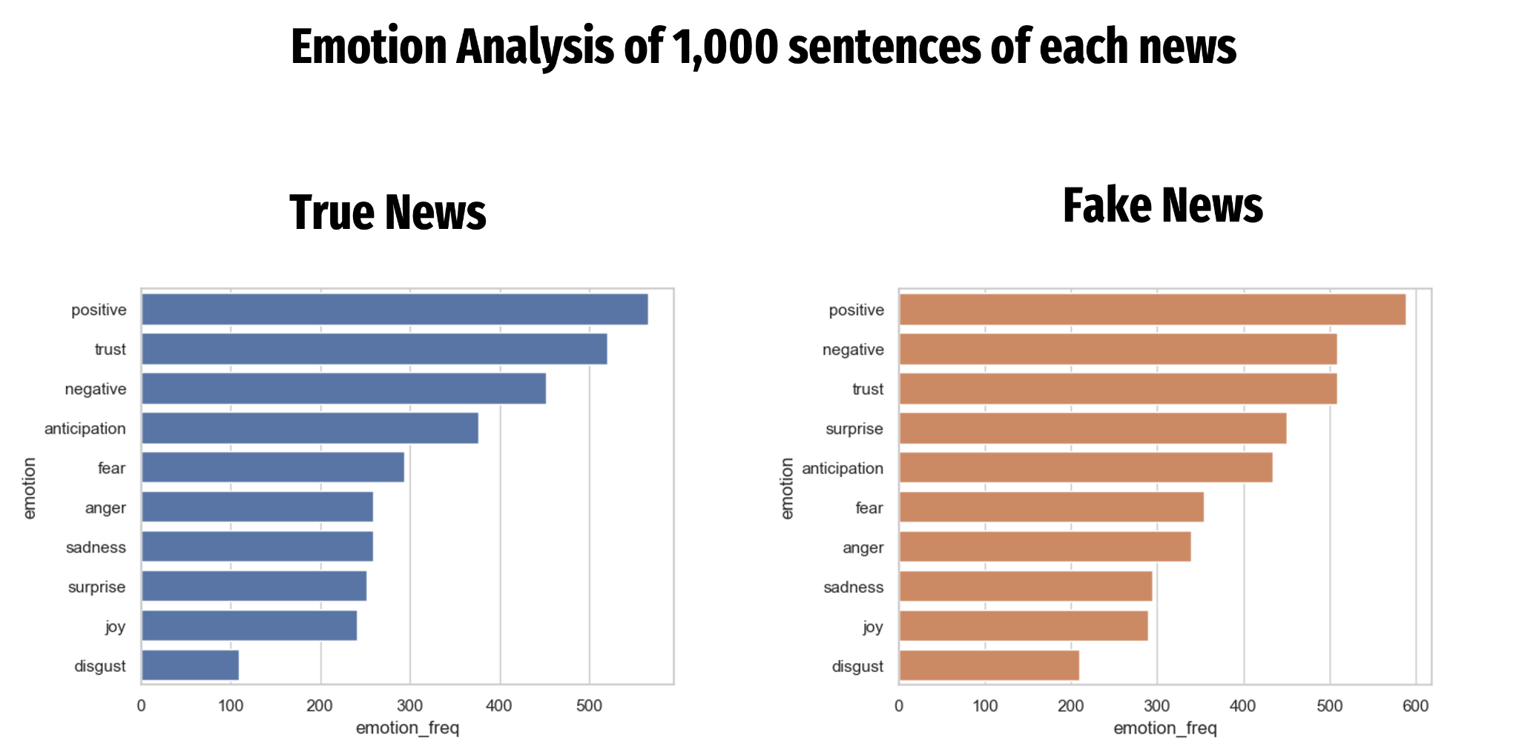

B. Pie Charts
Used for:
- sentiment proportion
- category comparison
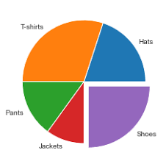

D. Histograms
Used for:
- text length distribution
- frequency spread
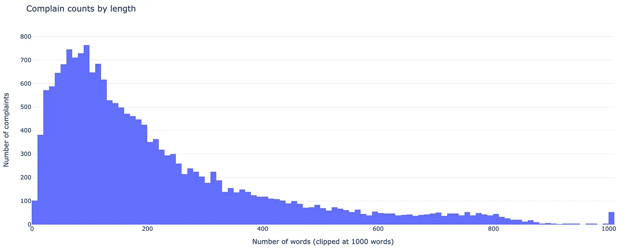

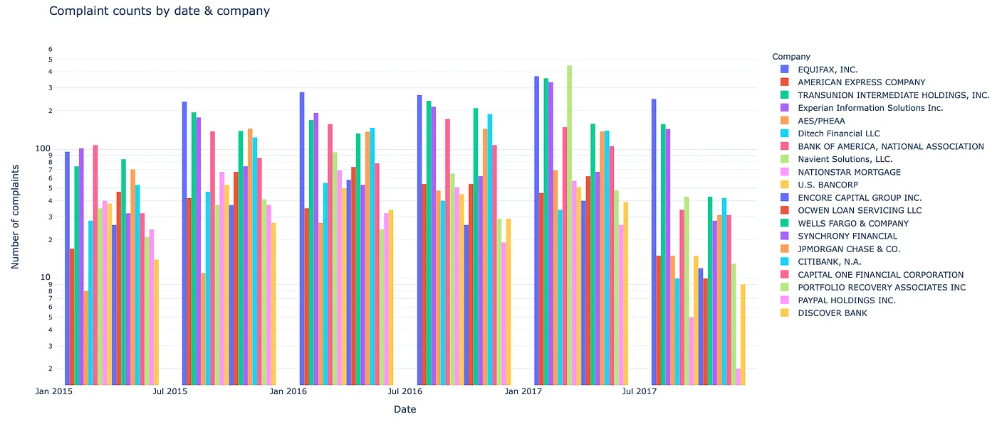

E. Heatmaps
Used for:
- word relationships
- similarity analysis
Mostly used in advanced NLP.
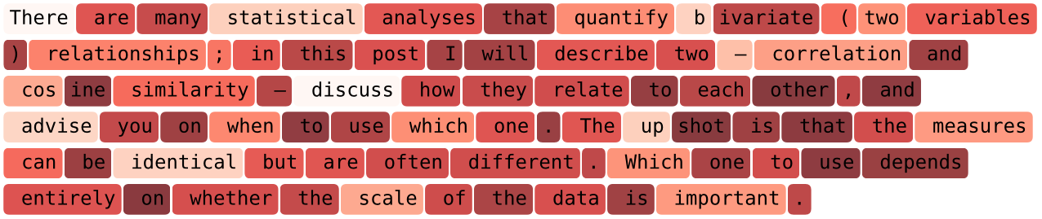
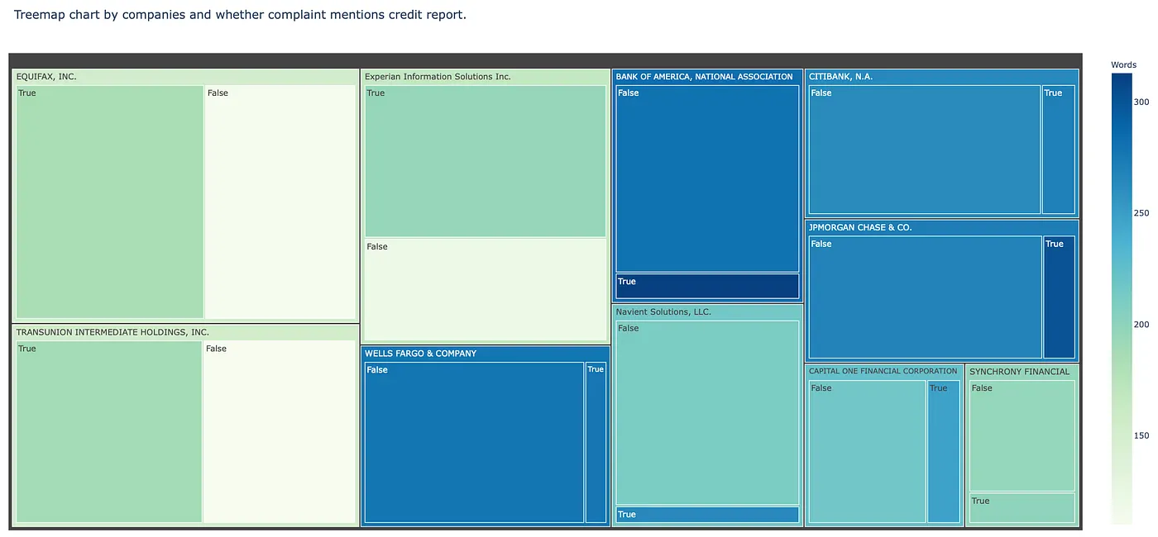

F. Bubble Chart

- word embeddings
- topic clusters
- keyword frequency
- semantic similarity

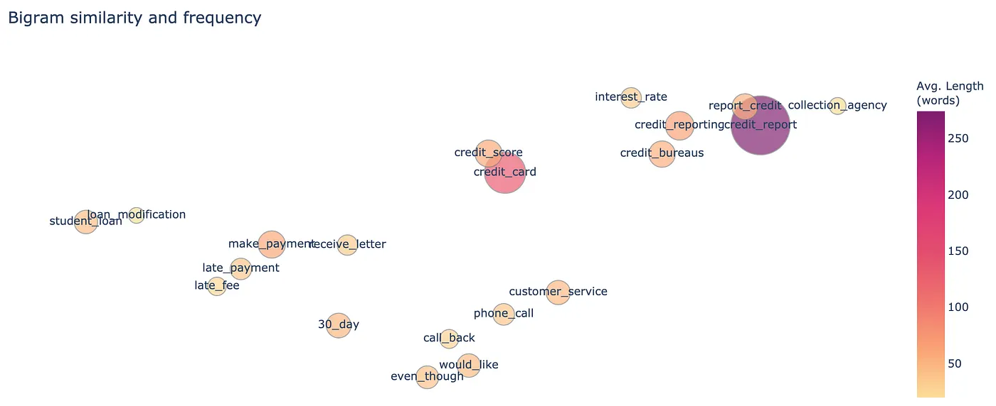

NLP analysis notebook
The notebook should demonstrate:
- text preprocessing
- exploratory text analysis
- feature engineering
- visualization
- NLP modeling
- interpretation of results.

